

Name : Lee Yuan Feng

Login ID : leeyuanfeng@oasis-portal.com

Course title : Executive Diploma in Culinary Arts & Hospitality Management

Subject Code : CA03 International Cuisine

Submitted date: **07/SEP/ 2017**

**Table of Contents**

|  |  |  |
| --- | --- | --- |
| **No** | **Details** | **Page** |
| 1 | Executive Summary | 2-3 |
| 2 | Introduction | 4 |
| 3 | Assignment Question |  |
|  | Part 1 | 5-11 |
|  | Part 2 | - |
|  | Part 3 | - |
|  | Part 4 | - |
| 4 | Conclusion | 12 |
| 5 | References | 13 |
|  | Appendix | - |

**Executive Summary**

In this assignment, we will learn about the purpose of this unit that is to be able to understand International Cuisine within Culinary Arts and Hospitality Management.

We will need to choose one dish from each cuisine. The cuisines are Chinese, Western and Indian. From each cuisine, we will need to recreate or alter the original recipe into our own recipe.

From doing this assignment, I learn that Chinese cuisine uses a lot color, smell and taste are the three traditional aspects used to describe Chinese food, as well as the meaning, shape and nutrition of the food. Cooking should be appraised from ingredients used, cuttings, cooking time and seasoning. It is considered inappropriate to use knives on the dining table. [Chopsticks](https://en.wikipedia.org/wiki/Chopsticks) are the main eating utensils for Chinese food, which can be used to cut and pick up food.

[Staple foods](https://en.wikipedia.org/wiki/Staple_food) of Indian cuisine include [pearl millet](https://en.wikipedia.org/wiki/Pearl_millet), [rice](https://en.wikipedia.org/wiki/Rice), [whole-wheat flour](https://en.wikipedia.org/wiki/Whole-wheat_flour), and a variety of [lentils](https://en.wikipedia.org/wiki/Lentil), such as masoor (most often red [lentils](https://en.wikipedia.org/wiki/Lentil)), toor ([pigeon peas](https://en.wikipedia.org/wiki/Pigeon_pea)), [urad](https://en.wikipedia.org/wiki/Urad_(bean)" \o "Urad (bean)) (black gram), and moong ([mung beans](https://en.wikipedia.org/wiki/Mung_bean)). Lentils may be used completely, dehusked—for example, dhuli moong or dhuli urad—or split. Split lentils, or [dal](https://en.wikipedia.org/wiki/Dal), are used extensively.[[19]](https://en.wikipedia.org/wiki/Indian_cuisine#cite_note-Johnston1958-19) Some [pulses](https://en.wikipedia.org/wiki/Pulse_(legume)), such as channa or cholae ([chickpeas](https://en.wikipedia.org/wiki/Chickpea)), [rajma](https://en.wikipedia.org/wiki/Rajma) ([kidney beans](https://en.wikipedia.org/wiki/Kidney_bean)), and lobiya([black-eyed peas](https://en.wikipedia.org/wiki/Black-eyed_pea)) are very common, especially in the northern regions. Channa and moong are also processed into flour ([besan](https://en.wikipedia.org/wiki/Gram_flour" \o "Gram flour)).

Many Indian dishes are cooked in [vegetable oil](https://en.wikipedia.org/wiki/Vegetable_oil), but [peanut oil](https://en.wikipedia.org/wiki/Peanut_oil) is popular in northern and western India, [mustard oil](https://en.wikipedia.org/wiki/Mustard_oil) in eastern India,[[18]](https://en.wikipedia.org/wiki/Indian_cuisine#cite_note-LocricchioMcConnell2004-18) and [coconut oil](https://en.wikipedia.org/wiki/Coconut_oil) along the western coast, especially in [Kerala](https://en.wikipedia.org/wiki/Kerala).[[20]](https://en.wikipedia.org/wiki/Indian_cuisine#cite_note-Seshadri2007-20) [Gingelly (sesame) oil](https://en.wikipedia.org/wiki/Sesame_oil) is common in the south since it imparts a fragrant, nutty aroma.[[21]](https://en.wikipedia.org/wiki/Indian_cuisine#cite_note-ShiHo2010-21) In recent decades, [sunflower](https://en.wikipedia.org/wiki/Sunflower_oil), [safflower](https://en.wikipedia.org/wiki/Safflower), [cottonseed](https://en.wikipedia.org/wiki/Cottonseed_oil), and [soybean](https://en.wikipedia.org/wiki/Soybean_oil) oils have become popular across India.[[22]](https://en.wikipedia.org/wiki/Indian_cuisine#cite_note-KumarDubey2006-22) [Hydrogenated](https://en.wikipedia.org/wiki/Hydrogenation) vegetable oil, known as [Vanaspati](https://en.wikipedia.org/wiki/Vanaspati" \o "Vanaspati)ghee, is another popular cooking medium.[[23]](https://en.wikipedia.org/wiki/Indian_cuisine#cite_note-Sharma-23) Butter-based [ghee](https://en.wikipedia.org/wiki/Ghee), or deshi ghee, is used frequently, though less than in the past. Many types of meat are used for Indian cooking, but chicken and mutton tend to be the most commonly consumed meats. Fish and beef consumption are prevalent in some parts of India, but they are not widely consumed except for coastal areas, as well as the northeast.

The cuisines of Western countries are diverse by themselves, although there are common characteristics that distinguish Western cooking from cuisines of Asian countries[[4]](https://en.wikipedia.org/wiki/European_cuisine" \l "cite_note-Kwan_1988-4) and others. Compared with traditional cooking of Asian countries, for example, meat is more prominent and substantial in serving-size.[[5]](https://en.wikipedia.org/wiki/European_cuisine#cite_note-Lin_1977-5) [Steak](https://en.wikipedia.org/wiki/Steak) and [cutlet](https://en.wikipedia.org/wiki/Cutlet) in particular are common dishes across the West. Western cuisines also put substantial emphasis on [grape wine](https://en.wikipedia.org/wiki/Grape_wine) and on sauces as condiments, seasonings, or accompaniments (in part due to the difficulty of seasonings penetrating the often larger pieces of meat used in Western cooking). Many dairy products are utilised in the cooking process, except in [nouvelle cuisine](https://en.wikipedia.org/wiki/Nouvelle_cuisine).[[6]](https://en.wikipedia.org/wiki/European_cuisine#cite_note-6) [Cheeses](https://en.wikipedia.org/wiki/Cheese) are produced in hundreds of different varieties, and [fermented milk products](https://en.wikipedia.org/wiki/Fermented_milk_products) are also available in a wide selection. [Wheat](https://en.wikipedia.org/wiki/Wheat)-flour bread has long been the most common source of [starch](https://en.wikipedia.org/wiki/Starch) in this cuisine, along with [pasta](https://en.wikipedia.org/wiki/Pasta), [dumplings](https://en.wikipedia.org/wiki/Dumpling) and [pastries](https://en.wikipedia.org/wiki/Pastry), although the [potato](https://en.wikipedia.org/wiki/Potato) has become a major starch plant in the diet of Europeans and their diaspora since the [European colonisation of the Americas](https://en.wikipedia.org/wiki/European_colonisation_of_the_Americas). [Maize](https://en.wikipedia.org/wiki/Maize) is much less common in most European diets than it is in the [Americas](https://en.wikipedia.org/wiki/Americas); however corn meal ([polenta](https://en.wikipedia.org/wiki/Polenta) or [mămăligă](https://en.wikipedia.org/wiki/M%C4%83m%C4%83lig%C4%83" \o "Mămăligă)), is a major part of the cuisine of [Italy](https://en.wikipedia.org/wiki/Italy) and the [Balkans](https://en.wikipedia.org/wiki/Balkans). Although flatbreads (especially with toppings such as [pizza](https://en.wikipedia.org/wiki/Pizza) or [tarte flambée](https://en.wikipedia.org/wiki/Tarte_flamb%C3%A9e" \o "Tarte flambée)), and rice are eaten in Europe, they do not constitute an ever-present staple. [Salads](https://en.wikipedia.org/wiki/Salad) (cold dishes with uncooked or cooked vegetables with sauce) are an integral part of European cuisine.

**Introduction**

Global cuisine is a gourmet food all over the world. Cooking is a culinary practice and a traditional characteristic style, usually associated with a particular region, country or culture. To become a global food, local, regional or national cuisine must spread throughout the world, its food throughout the world. Food preservation, storage, transportation and production have made significant progress in the last century, and today many countries, cities and regions have traditional cuisine and many other global delicacies.

For example:

**Japan cuisine**

* Sushi
* Sashimi
* Sake
* Lunch
* Tempura
* Ramen
* Oolong face

**India cuisine**

* Tosi
* Curry chicken
* Chapatti
* biryani

**Italia cuisine**

* Pizza
* Spaghetti
* Pesto
* Salami

**Korea cuisine**

* Korean fried rice cakes
* Kimchi fried rice
* Korean barbecue
* Korean fried chicken

**Assignment Questions**

**Assignment 3**

You should create your own dish from each international cuisine listed.

Required:

Choose one dish for each cuisine:

(i) Chinese cuisine (ii) Indian Cuisine (iii) Western Cuisine

You should be able create own recipes.

1. Chinese cuisine

**Original Chow Mein**

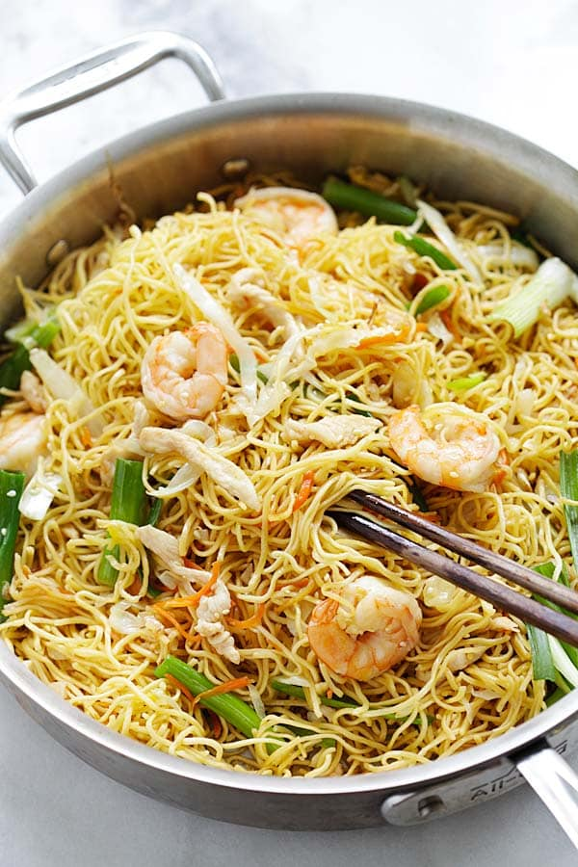

**Chow Mein Recipe**

Serves 2 | Prep Time: 10 Minutes | Cook Time: 5 Minutes

**Ingredients:**

* 8 oz. steamed chow mein
* 1 tablespoon soy sauce
* 1 tablespoon oyster sauce
* 1/2 teaspoon sugar
* 1/2 teaspoon Chinese dark soy sauce
* 2 tablespoons water
* 2 tablespoons oil
* 3 garlic cloves, finely minced
* 2 oz. chicken, cut into thin strips
* 6 shrimp, shelled and deveined
* 1/2 cup shredded cabbage
* 1/4 cup shredded carrot
* 2 stalks scallions, cut into 2-inch strips

**Method:**

Soak the steamed chow mein in cold water for about 5 minutes. Rinse a few times until the water turns clear and the chow mein is soft. Drain the excess water and set aside. (Don’t over soak the chow mein or the noodles will get limpy and soggy.)

In a small mixing bowl, mix the soy sauce, oyster sauce, sugar, dark soy sauce and water together. Set aside.

Heat up a skillet or wok with the oil. Add in the garlic and stir-fry until light brown or aromatic. Add the chicken and shrimp and stir fry until they are half cooked. Add the shredded cabbage and carrot into the wok and do a few quick stirs. Add the noodles and the soy sauce mixture. Continue to stir fry until the noodles are well combined with the soy sauce mixture and completely cooked through. Add the chopped scallions, do a few final stirs, dish out and and serve hot.

**Own Recipe：**

**Fusion Chow Mein**

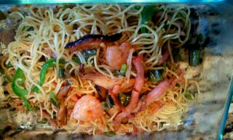

**Ingredients**

* 1 tsp soy sauce
* ¼ tsp sesame oil
* ¼ tsp white pepper
* 1 tsp corn flour
* 5 or more mushrooms
* ½ bag of beansprouts
* 1 bag (300g) noodles
* 250ml hot water
* 2 tbsp dark cooking caramel
* 1 tbsp soy sauce
* 1 tsp cracked white pepper
* ¼ tsp sesame oil
* 1 tbsp olive oil
* 1 clove garlic (minced)
* 200g seafood （shrimp, squid）
* 20g Capsicum

1. Indian Cuisine

**Original Curry Chicken**

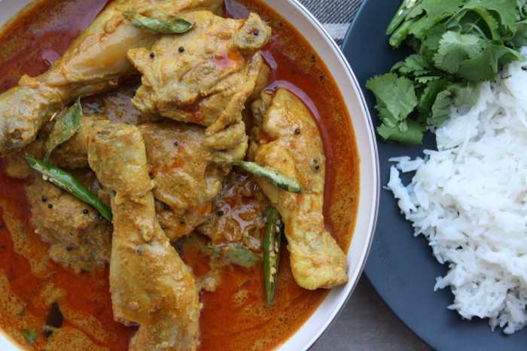

**For the paste;**

* 2 tbsp roasted peanuts
* 1 tbsp desiccated coconut
* 1 tbsp coriander seeds
* 1 tsp cumin seeds
* 1 tbsp sesame seeds

**For the chicken curry**;

* 1 kg chicken on the bone (legs and thighs are great)
* 3 tbsp vegetable oil
* 1 tsp mustard seeds
* 8-10 curry leaves
* 130gms white onions thinly sliced
* 1 tbsp garlic ginger paste (5 cloves garlic & 1” ginger ground to a paste)
* 1 tsp mild chilli powder
* 1 tsp turmeric powder
* 300mls water
* 2 tsp tamarind paste
* Salt to taste
* Handful coriander for garnish

**Own Recipe:**

**Fusion Curry Chicken**

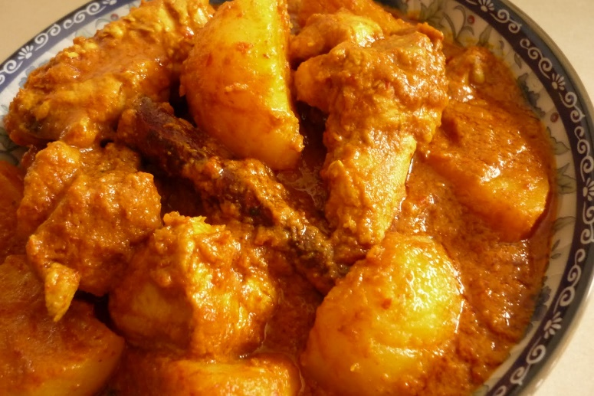

**Ingredients:**

* 250g instant curry paste
* 8 potatoes
* 8 chicken legs
* some shallots
* 2 lemongrass
* 1 tablespoon oil
* 500ml water
* 100ml coconut milk
* Some curry leaves
* 20g peanut
* 2 carrot
* 4 tomatoes

1. Western Cuisine

**Pizza margherita**

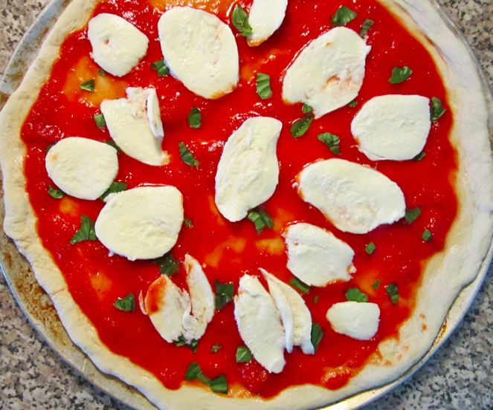

**Ingredients:**

- Basic Pizza Dough

- 4 cups Molino Caputo Tipo 00 flour (done all-purpose flour)

- 1 ½ cups, plus 2 Tbs water (110F-115F)

- 2 tsp kosher salt

- 1/2 tsp dry active dry yeast

**Topping：**

- 6 tbs extra virgin olive oil

- 1 can (14oz) whole peeled Italian tomatoes (San Marzano), pureed

- 12 oz buffalo mozzarella cheese ball or fresh cow's milk mozzarella

- 24 basil leaves

- 2 tsp sugar

- 1 ½ cups water

**Own Recipe:**

**Pizza margherita**

**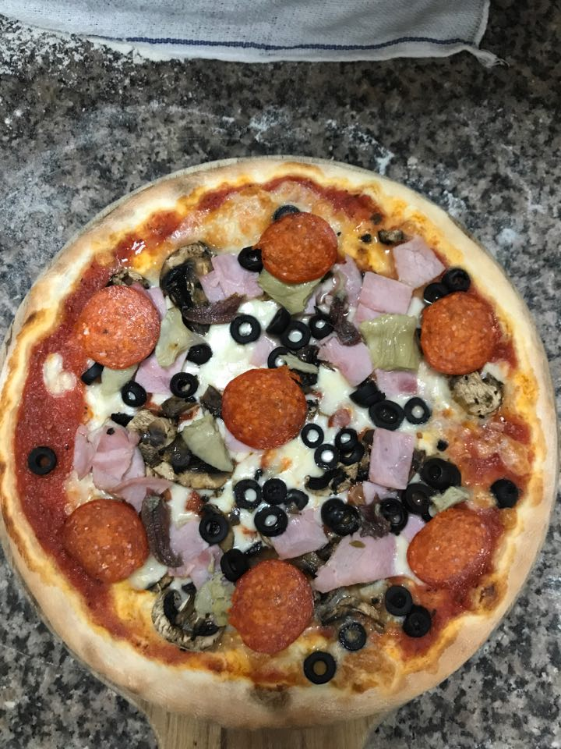**

**Ingredients:**

* Basic pizza dough
* 5.2kg pizza flour
* 300ml olive oil
* 80g milk
* 70g salt
* 60g sugar
* 2300ml water

(For 30 tablets pizza dough)

**Topping:**

* Tomato Sause
* Mozzarella cheese
* Some Pork salami
* Some Ham
* Some Artichokes
* Some Mushrooms
* Some Anchovies
* Some Black olive

**Conclusion**

For the conclusion, this module has teach me that the factors affecting food ways and culinary practices are as follows:

1. Geographical Location (Malaysia and USA)
2. Climate (hot and cold)
3. Topography (hilly area or flat area)
4. History (family tradition)
5. Religion

* Buddhism (can’t eat beef because it is symbolic to the gods)
* Christianity (special Christmas dish)
* Confucianism (no dietary restrictions because it is a philosophy)
* Hinduism (can’t eat beef because it is symbolic to the gods)
* Islam (pork)
* Judaism (The laws related to food are called 'kashrut')
* Seventh day Adventists (according to the old testament in the bible)
* Shintoism (Japanese ethnic)

1. Factors Affecting Cultural Foods (Indian, Chinese, Japanese, Malay)
2. Economic Factors that Affect Cultural Food (rich and poor)
3. Health Concerns (diet, healthy food)

**References**

1. Dias (1 January 1996). [Steward, The](https://books.google.com/books?id=SRx9I2BqSpMC&pg=PA215). Orient Blackswan. p. 215. [ISBN](https://en.wikipedia.org/wiki/International_Standard_Book_Number) [978-81-250-0325-0](https://en.wikipedia.org/wiki/Special:BookSources/978-81-250-0325-0). Retrieved 29 June 2012.
2. Gesteland, Richard R.; Gesteland, Mary C. (23 February 2010). [India: Cross-cultural Business Behavior : for Business People, Expatriates and Scholars](https://books.google.com/books?id=tXqDRS4IN1IC). Copenhagen Business School Press DK. p. 176. [ISBN](https://en.wikipedia.org/wiki/International_Standard_Book_Number) [978-87-630-0222-6](https://en.wikipedia.org/wiki/Special:BookSources/978-87-630-0222-6). Retrieved 29 June 2012.
3. Chandra, Sanjeev; Chandra, Smita (7 February 2008). ["The story of desi cuisine: Timeless desi dishes"](http://www.thestar.com/article/300969). [Toronto Star](https://en.wikipedia.org/wiki/Toronto_Star).
4. ["Indian food– Indian Cuisine of india vernon – its history, origins and influences"](http://www.indianfoodsco.com/Classes/CulinayHistory.htm). Indianfoodsco.com. Retrieved 23 June 2009.
5. D Balasubramanian (16 October 2008). ["Potato: historically important vegetable"](http://www.hindu.com/seta/2008/10/16/stories/2008101650731500.htm). The Hindu. Chennai, India. Retrieved 26 June 2012.